Standardized Protocol for Anatomically Correct Orientation of 3D Transesophageal Images of the Thoracic Aorta
Alana Choy-Shan, MD; Muhamed Saric, MD, PhD; Gila Perk, MD; Itzhak Kronzon, MD.
New York University Langone Medical Center, New York, NY. Background

The utility of 2D transesophageal echocardiography (TEE) for imaging of the thoracic aorta was established decades ago. The recently developed live 3D TEE is becoming the ultrasound test of choice for visualizing this vessel. However, there are no standard ways of displaying 3D TEE images of the thoracic aorta. In addition, current 3D TEE imaging protocols require constant fallback to 2D TEE images for orientation. The purpose of this study was to develop a simple imaging protocol that (1) displays 3D TEE images in a proper anatomic orientation; and (2) allows for 3D TEE imaging of the entire thoracic aorta with minimal reliance on 2D TEE images.

Methods

Real-time 3D zoom TEE images of the aorta were acquired at a 0⁰ transducer angle in 50 consecutive patients referred for TEE. The imaging was started at the deep esophageal level (Figure 1, Panel 1). The initial 3D TEE image (‘opening scene’, Panel 2) was tilted down using the trackball to reveal the intimal surface of the aorta (Panel 3). Image was then rotated in the Z axis by 180⁰ in order to place the image in the correct anatomic orientation (Panel 4). We refer to this tilt-down-and-rotate-in-Z technique as TOWN-Z maneuver. Once the images were properly oriented, the TEE probe is then slowly withdrawn to visualize the entire aorta in 3D zoom mode (Figure 2).

Results

The TOWN-Z maneuver allowed for rapid placement of aortic images in proper anatomic orientation with regard to the superior-inferior axis in all patients. The maneuver also allowed visualization of the entire descending thoracic aorta and the aortic arch in the 3D zoom mode without reliance on 2D images (Figure 2). The aortic arch is depicted as seen from the patient’s back. Figure 3 demonstrates a variety of aortic pathologic findings noted while utilizing the TOWN-Z maneuver. This novel imaging protocol also allowed for easy identification of the azygos vein and the origins of the left subclavian and the left common carotid arteries (Figure 4).

Conclusion

A simple standardized method is devised for placement of 3D TEE images of the thoracic aorta into anatomically correct positions and for visualization of the entire aorta in 3D TEE mode without reliance on 2D images. The TOWN-Z maneuver is intuitive to the operator since gradual withdrawal of the TEE probe in the cranial direction reveals the proximal segments of the aorta along the top edge of the monitor. The protocol also allows for rapid analysis of imaged aortic segments and for precise localization of anatomic landmarks and pathologic findings.

Figure 1: The TOWN-Z Maneuver | Figure 2: 3D TEE Reconstruction of Thoracic Aorta
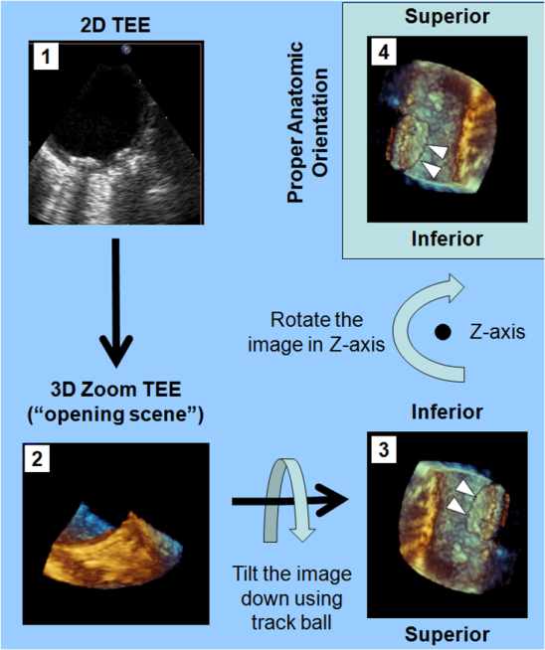  White arrow heads point to atherosclerotic plaque. | 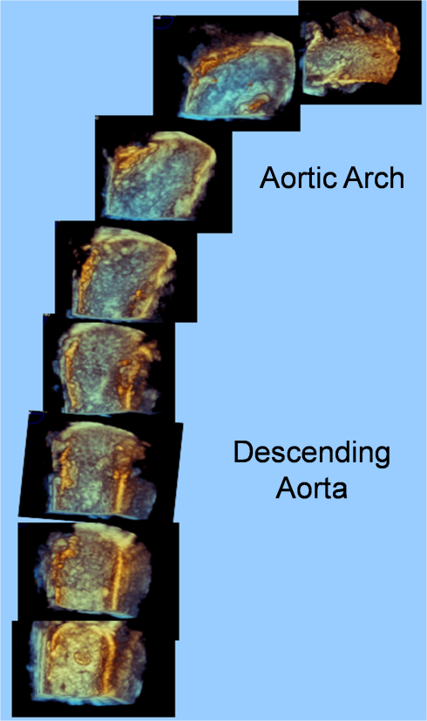
Figure 3: Various Aortic Pathologies Visualized by 3D TEE
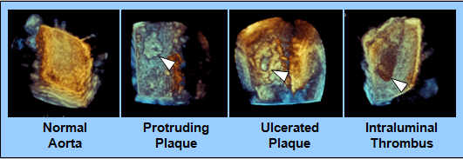
Figure 4: Aortic Branches Visualized by 3D TEE
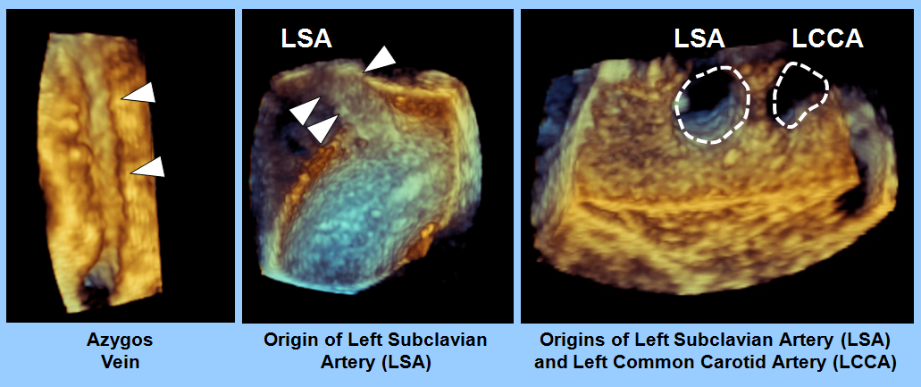
Abbreviations: LSA, left subclavian artery; LCCA, left common carotid artery.

